

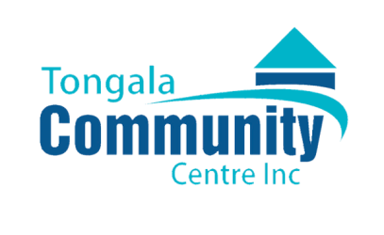

FREE TONGALA SENIORS EXPO

PRIZES TO BE WON
GUEST SPEAKERS

LOCAL SERVICES & GROUPS
Morning Tea
Wednesday September 24th
10:00am – 1:00pm
Tongala Town Hall

