Join us for
FREE FREE FREE FREE
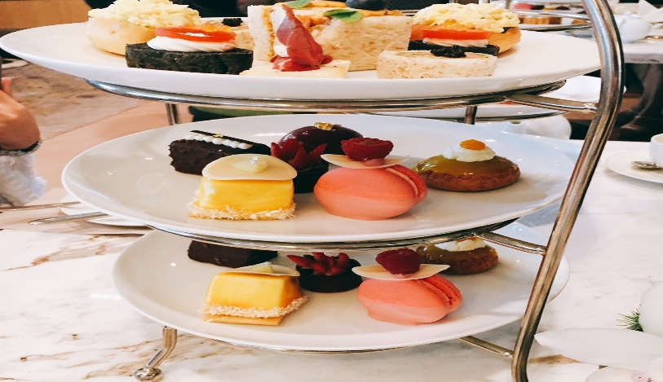
HIGH TEA

Friday 12th of September

@ 10.30am
R.S.V.P. ON : 03 58591268

for your seat at the table
