**Child Care**

**Sun Protection Policy**

**Rationale**

Too much ultraviolet (UV) radiation from the sun can cause sunburn, skin damage, eye damage and skin cancer. The damage done to the skin from even one episode of overexposure to the sun can never be repaired.

Australia has the highest incidence of skin cancer in the world, with two in three Australians developing some form of skin cancer during their lifetime. Overexposure to the sun during childhood and adolescence is known to be a major cause of skin cancer.

Our Sun Protection Policy is followed from the beginning of September until the end of April and whenever the UV index level reaches 3 and above.

**Aim**

Tongala Community Activities Centre Inc Child Care Sun Protection Policy has been developed to ensure that all children and staff are protected from over exposure to UV radiation from the sun.

**Strategies**

* All children and staff use a combination of sun protection measures whenever UV index levels reach 3 and above. Particular care is taken from 10 am to 2 pm (11am and 3 pm daylight saving time) when UV index levels reach their peak during the day.
* To assist with the implementation of this Policy, educators are encourages to access the local sun protection times via the SunSmart widget on the service’s website, the free SunSmart app or at sunsmart.com.au .
* TCAC Child Care sun protection practices consider the special needs of infants. Babies under 12 months of age are kept out of the direct sun.

**Outside Play**

The Committee of Management of TCAC Child Care ensures there is sufficient shelter and tress providing shade in the playground. Child care staff will encourage children to play in the shaded areas within the playground. Children who do not have appropriate hats or outdoor clothing will be asked to play in the shaded areas only, or be loaned a hat from the centre.

**Protective behaviours and practices for outside activities**

***Hats***

Children are required to wear hats that protect their face, neck and ears (legionnaire, broad brimmed or bucket hats). Please note baseball caps do not offer enough protection and are therefore not recommended. See examples below.

***Clothing***

The requirements are loose fitting clothing that covers as much skin as possible. Please note singlet tops do not offer enough protection and are therefore not recommended.

***Sunscreen***

SPF 30+ broad spectrum, water resistant sunscreen is available for both staff and children’s use. Sunscreen is applied at least 20 minutes before going outdoors and reapplied every two hours when outside.

***The child care educators will act as role models by:***

* Wearing sun protective hats and clothing.
* Applying SPF 30+ broad spectrum, water resistant sunscreen.
* Seeking shade whenever possible.
* Supporting duty of care and regulatory requirements.

***Sharing information about sub protection***

* The children learn about skin and ways to protect their skin from the sun.
* Children are encouraged and supported to develop independent sun protection skills.
* The sun Protection Policy is re-enforced through staff and children’s activities, and displays on notice boards.

***When a child is enrolled into child care parents will***

* Be informed of the Sun Protection Policy.
* Be asked to provide a suitable hat for their child.
* Permission will be sought for the child care educators to apply the sunscreen.

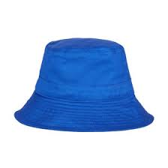 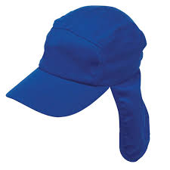 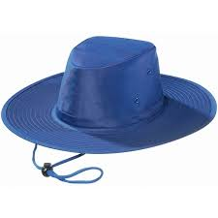

Bucket hat Legionnaire hat Broad brimmed hat

***Resources***

Sunsmart policy for early childhood

***Responsible Officer – TCAC Coordinator***

***Date of approval – 11/02/2019***

***Date of review – 11/02/2021***